Question 30:
Create a registration form for employee database management and display the collected
document by using the JSP program.

Program:
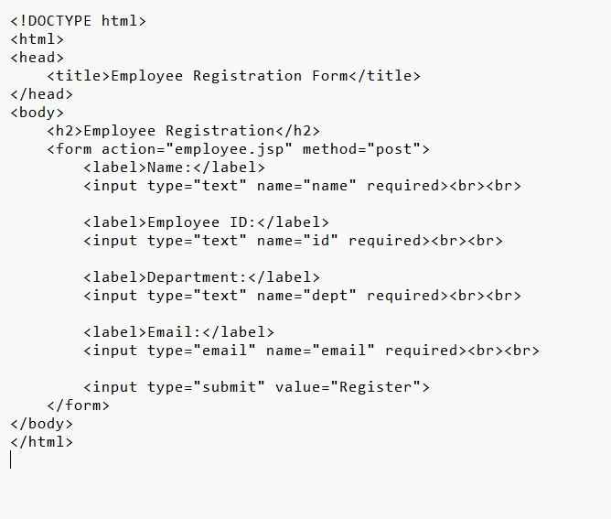

Output:
